Doctoral Program in

Natural Resources and Environment

RESEARCH PLAN
Data of the doctoral student
Name and sumame

Títle of the Research Plan

Keywords (up to 5 in alphabetical order)

Thesis director
Name and sumame

Thesi codirector (if applicable)
Name and sumame

Tutor or speaker (if applicable))
Name and sumame

Degree: University and year:

Master’s degree: University and year:

Table of contents
1. State of the art 3
2. Objectives and hypothesis of the thesis 3
3. Description of the methodology 4
4. Work Plan (Gantt chart) 4
5. Expected results 4
6. Publications and plan for future publications in indexed journals and/or patents 4
7. Participation in congresses held and planned 5
8. Participation in national and international research projects 5
9. Bibliography 5

State of the art
Description of the previous theoretical basis on which the doctoral thesis is based. This chapter is
Essential to explain the contributions to knowledge made by the thesis in the current state of knowledge. It is important that the works are clearly cited and all references are detailed in section 9.
Maximum legth of 5 pages.
In case of entering tables and figures follow the following format and enter the description by inserting the title with the right mouse button: Table 1. Detailed description of the table contents (indicate source)
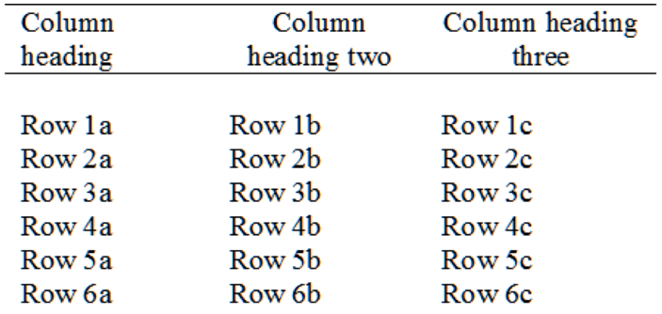

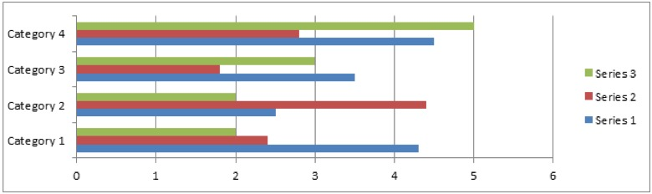
Figure 1: Detailed description of the content of the figure (if it is not your own source, please indicate it).

Objectives and hypothesis of the thesis
Clearly define the overall objective of the thesis, specific objectives and starting hypotheses .

Description of the methodology
Describe the methodology, material and methods and/or description of the models necessary to carry out the doctoral thesis.
Maximun length 3 pages.

Work Plan (Gantt chart)
Specify the timing of the tasks to achieve the specific objectives detailed in section 2. Include the planning of the derived items as detailed in section 6

Expected results
Description and discussion of previous results obtained and expected.
Include the initial and final TRL of the thesis, if applicable.

Publications and plan for future publications in indexed journals and/or patents
Remember that in order to be accepted as publications associated with the thesis, the affiliation of the University of the doctoral program must be stated.
E.g. Author ¹, Author ², Author ³,
¹Departament of industrial Mining Engineering and ICT, Polytechnic School of Engineering of Manresa, Polytechnic University of Catalonia.

Participation in congresses held and planned

Participation in national and international research projects

Bibliography
Follow the UNE-ISO 690 standard.

Signed:

The doctoral student  Signature and date: | Director’s approval  Signature and date:
Co-director approval  Signature and date: | Tutor’s approval  Signature and date:

The evaluation board of the research plan is made up of:
- President:
- Vocal 1:
- Vocal 2:

Rate the submitted PR:
- Satisfactory
- Not satisfactory

Place and date

Signature of the chairman of the evaluation board:

Observations of the court:

